Merge K sorted arrays
Problem
Given k sorted arrays, our task is to combine all of them in such a way that the final array is also a sorted array.

Example
Given the following sorted arrays
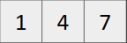, 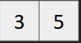, 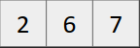
We need to output
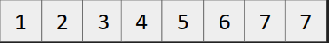

Brute force approach
- Take two arrays and merge them into a sorted array. Repeat this process until we are left with one array. {We have covered merge two sorted arrays in merge sort)

Dry Run
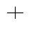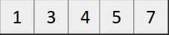




Efficient Solution (Using heaps)
- Create a MinHeap of pairs, i.e.
priority_queue<pair<int,int>, vector<pair<int,int>>, greater<pair<int,int>> >
- Insert {first element, array number} of all the sorted arrays into MinHeap.
- Pop the top element from the MinHeap and store it into the answer array. Insert the next element of the sorted array into the MinHeap.
- Keep track of indices of the elements that are being inserted in the answer array using an index array[] whose indices denote the array number and elements represent the index of the last element inserted from that particular array.

